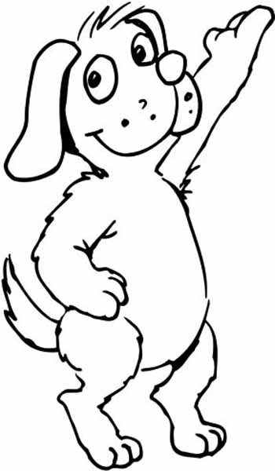
BOARDING GUIDELINES

MONTVALE ANIMAL HOSPITAL
115 Chestnut Ridge Rd. Montvale, NJ 07645
Phone: (201) 391-4342 Fax: (201) 391-4344
montvaleah@yourvetdoc.com

Admission Times: Dismissal Times:
Monday - Friday 8:30 AM to Noon and 2:00 PM to 4:00 PM Monday - Friday 8:30 AM to 3:30 PM
Saturday 8:30 AM to Noon Saturday 8:30 AM to Noon

A HALF DAY CHARGE OF $40.00 WILL BE CHARGED FOR ALL PETS THAT ARE NOT PICKED UP BY 12:00 PM ON DAY OF PICK UP.

**No Sunday Admission or Discharge**

ALL DOGS MUST BE CURRENT ON THE FOLLOWING:
Distemper/Parvo Vaccination
Rabies Vaccination
Influenza Vaccination
Bordetella (if never received, would need to be administered 72 hrs prior to boarding)
Negative Fecal in the last 6 months

We pride ourselves on keeping our kennel flea free, therefore all dogs admitted are treated with Capstar to ensure a flea free environment for your pet. This is a non-toxic caplet given once orally on the way in and 100% effective at killing adult fleas within hours of consumption ($20.50)

MEDICATION/ DIETARY INFORMATION:
Please note we are not a medical boarding kennel and staff is not on premises overnight. We can only board pets that do not need 24 hour supervision for serious medical conditions.

We recommend that your dog stay on their regular diet to ensure there is no gastrointestinal upset.

All dogs are individually walked outdoors in our fenced in backyard at least five times daily for fresh air and exercise! Bedding is provided for your pets comfort

Boarding Fees:
Bed & Breakfast Stay (up to 60 lbs.).........................................................$80/night
Bed & Breakfast Stay (61 to 90 lbs.).........................................................$86/night
Bed & Breakfast Stay (over 90 lbs.)........................................................ $92/night
*Boarding fees are subject to NJ State Sales Tax

Medication Fees:
Once a day medication administration- $5.00
Twice a day medication administration- $10.00

Day Care is $62.00
If pets are not picked up by closing, they will stay overnight and the appropriate boarding fee will be applied at pick up.

